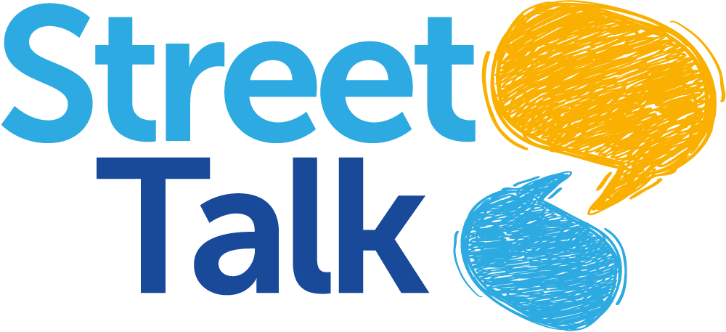
Please return by email to:
pippa@street-talk.org.uk

Street Talk Psychotherapy

Street Talk offers one to one psychotherapy to women with no charge to the women. The service is designed to overcome those obstacles which exclude the most marginalised people from accessing therapy.

Street talk understands the needs of clients with multiple-complex needs and provide flexible psychotherapy model to ensure that clients are supported at a pace and in a manner that is comfortable to the women we support.

There is no end date to the offer of psychotherapy, with clients able to engage in the service for as long as needed.

Referrer Details
Name
Contact Phone
Email Address
Organization

Client Details
Full Name
Current Address
Contact Phone
Date of Birth
GP Practice
Ethnicity | ☐White British ☐White Irish ☐ White European ☐Other White background  ☐Gypsy/Romany/traveller  ☐Black British ☐ Black Caribbean ☐Black African ☐Black Other  ☐Mixed White & African ☐Mixed White & Asian ☐Mixed Other  ☐Middle Eastern  ☐ Asian British ☐Asian Pakistani ☐Asian Indian ☐Asian Bangladeshi ☐Asian Other  ☐Latin American  ☐Any other Background: please detail  ☐Declined

